**Bare Breasted Dresses and Fashion Tips for Ladies with Small Breasts**

Bare breasted dresses are for the bold and the risk takers. They are not just your normal dress, but rather, they add a sense of elegance and high fashion that is punctuated with a bold look. Bare breasted dresses and other revealing apparel can be worn by ladies with small breasts too.





Ladies with small breasts need not fear anymore because they can also rock that fashion in all sorts of ways. If you are the woman who likes to take risks, invest in a quality bare breasted dress. You can pair the dress with other clothes and accessories to complete the look.

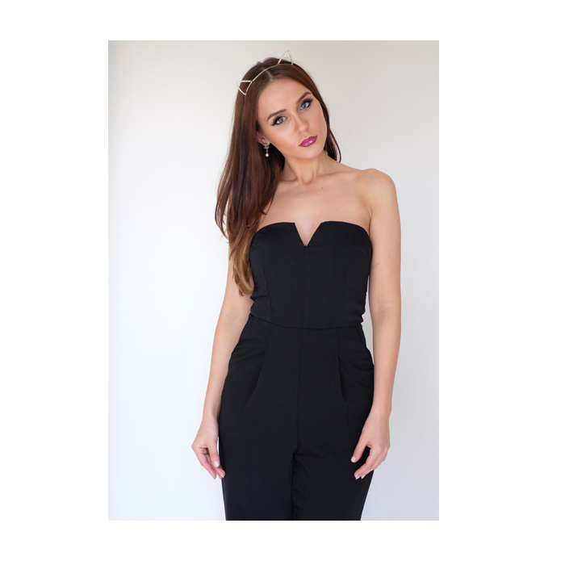

**Try the Plunging Neckline**

Just because your breasts are small does not mean that you can’t rock that plunging neckline. It can look good on you! Try this look with bare breasted dresses that plunge lower or unbuttoned shirts that slide lower.





**Be Bold on Colors**

Colors can work well for you if you have small breasts. They will draw more attention to your apparel, than on the chest. Great tops that have bold prints and exciting colors can work well for you.



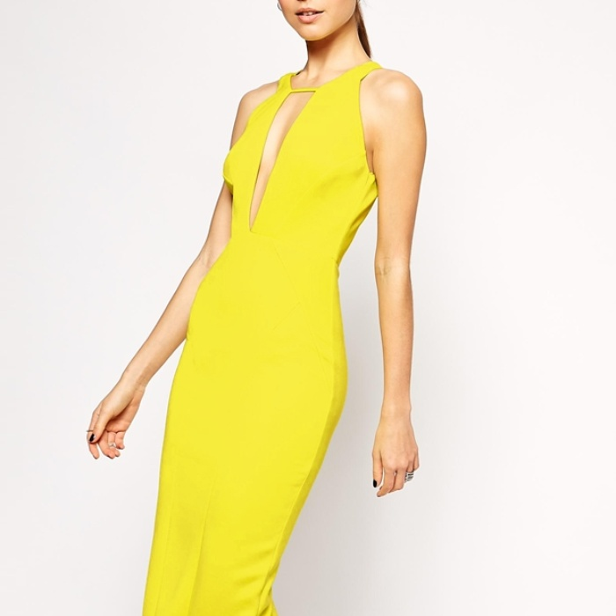

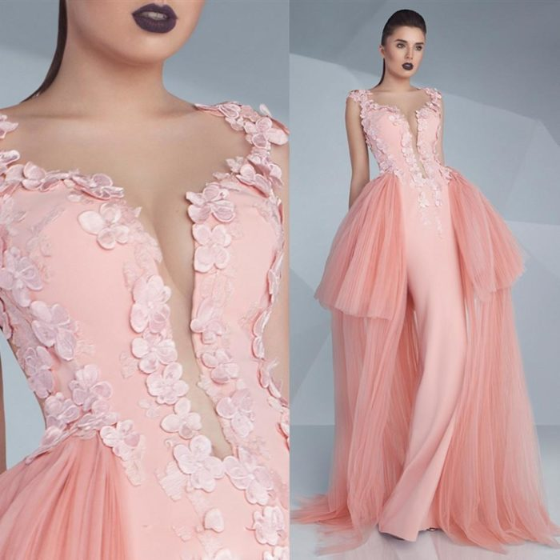

**Waist Matters**

Draw more attention to your slim waist using clothes that focus on your waistline. This will draw less attention to your breasts. There are great bare breasted dresses that flatter the waist and work well to create a nice silhouette.

 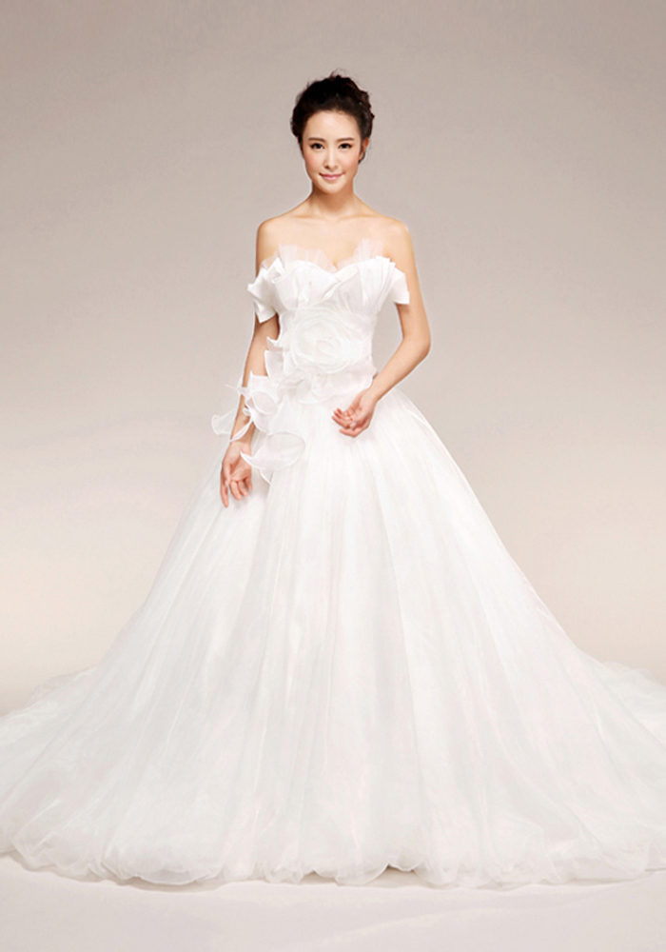

**More Accessories**

You can use accessories that will create an illusion of a fuller chest like necklaces with big beads. You can also try tops that have ruffles or frills. If you decide to rock the bare breasted dress, ensure that you accompany it with some accessories that have bold colours.

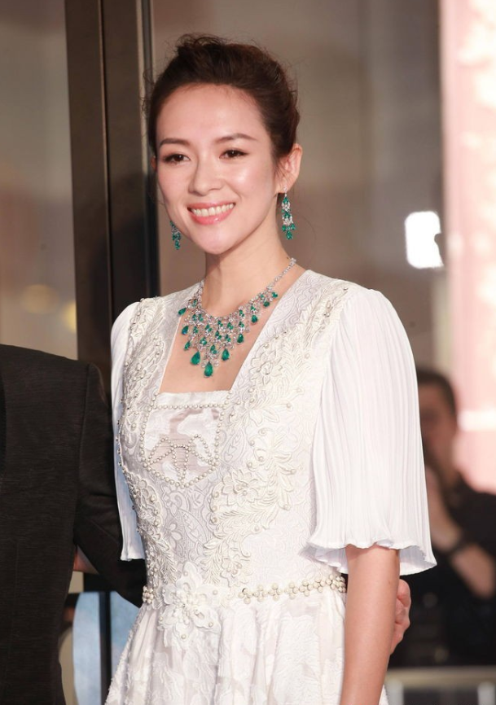





**More Attention to your Arms Legs and Shoulders**

Give your shoulders and arms more attention by wearing outfits that shift the attention from your bust. Tops that have high necklines are a good choice.



